A SPECKLED OFF-WHITE GLAZED CERAMIC LAMP WITH HANDLE BY ACCOLAY

France, c. 1960's

EA3395
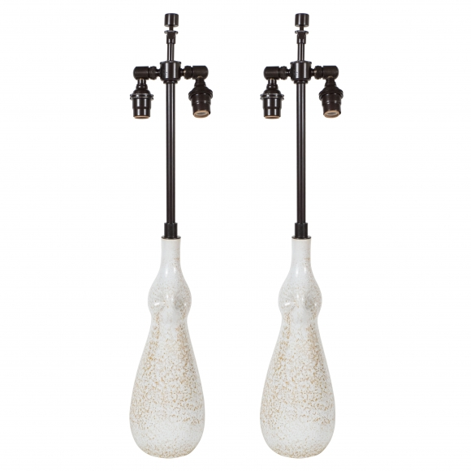

A speckled off-white glazed ceramic Vase with handle, by Accolay, converted into a table lamp.
H: 22 Diam: 4.5 in.

