A LARGE WHITE CRACKLE CERAMIC VASE LAMP ATTRIB. TO ZACCAGNINI

USA, c. 1950's

EA3686
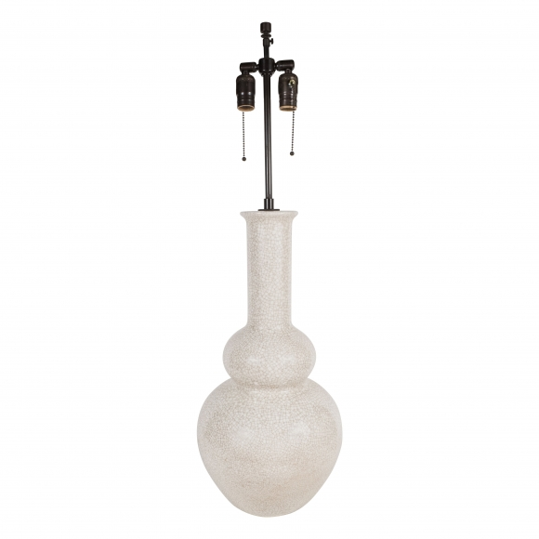

H: 23.75 Diam: 11 in.

