CHINESE CHARTREUSE CRAQUELURE LAMP

China, 20th Century

EA3820
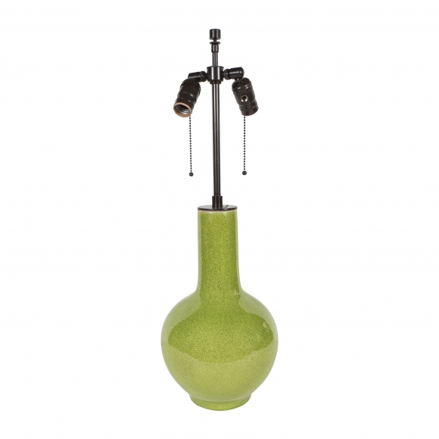
H: 26.5 Diam: 8 in.

