AMERICAN WHITE CERAMIC LAMP

USA, c. 1950's

EA3978A
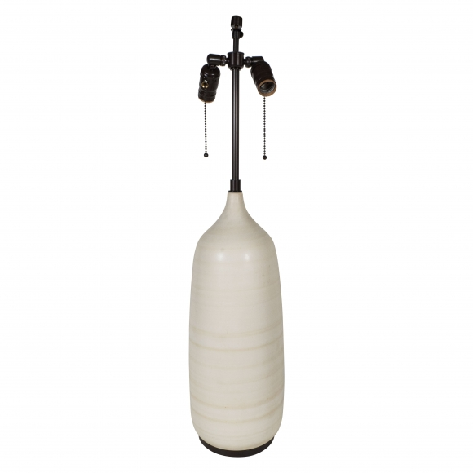

H: 31 Diam: 7.5 in.

