WHITE PIERCED METAL PEDESTAL BOWL IN THE STYLE OF MATEGOT

France, c. 1950's

EA4025
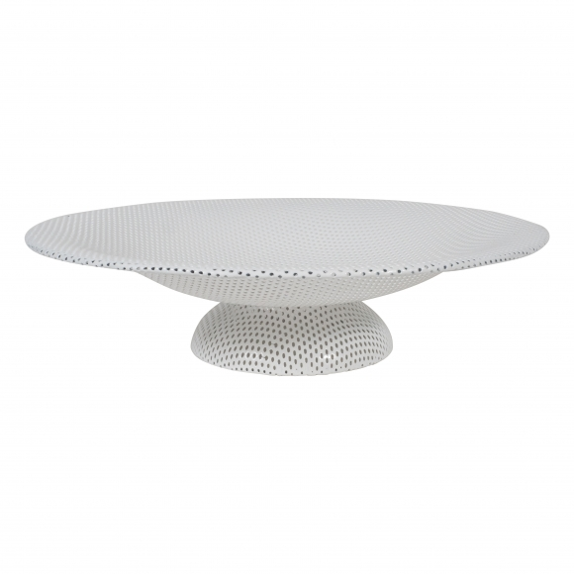
H: 3.5 Diam: 13.75 in.

