SET OF THREE ALDO TURA PARCHMENT RECTANGULAR NESTING TABLES WITH POLISHED BRONZE

Italy, c. 1960's

EA4051

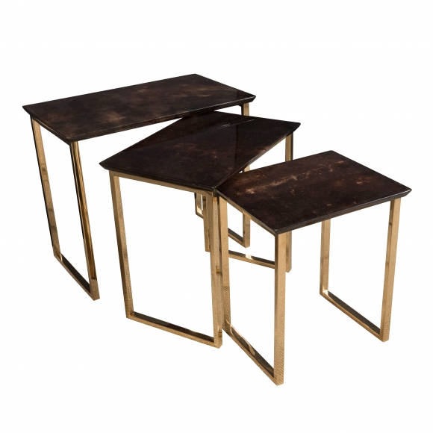

Largest: H: 10 to 17 10 to 0 by 12 in.

