SUPEREGO TABLE WITH BLUE AGATES BRASS BASE AND LUCITE TOP

Italy, Contemporary

EA4094

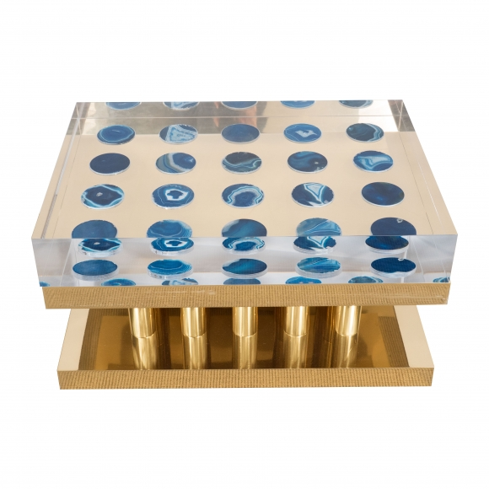

Dimensions: H: 14” W: 27.5 D: 20”
Price: $12,000

