ITALIAN MODERNIST MIRROR IN A CUSHION SHAPE

Italy, c. 1950

EA4098

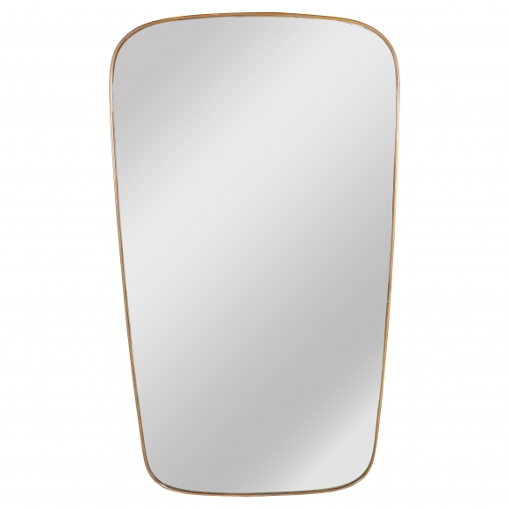

Dimensions: W: 25” Top & Bottom Center W: 25.75” D: 1” H: 50”
Price: $5,500

