ITALIAN MODERNIST MIRROR IN A CUSHION SHAPE

Italy, c. 1950

EA4099

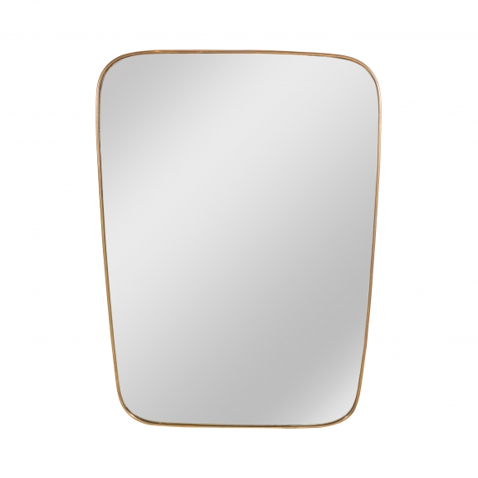

H: 37.5 W: 25.5 in.

