LARGE FONTANA ARTE FLOOR LAMP

Italy, c. 1955

EA4104

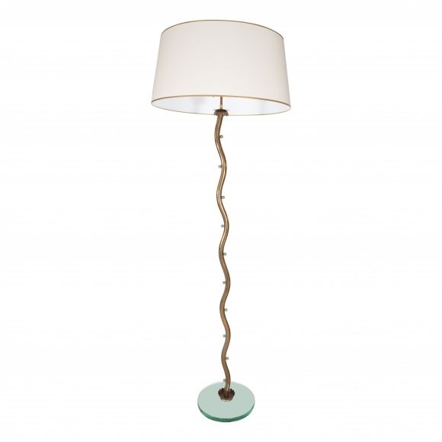

Large Fontana Arte floor lamp, glass base with metal serpentine support with green ball detail
H: 78.5 Diam: 14 in.

