PAIR OF GIBBINGS WHITE MARBLE LAMPS, HANSEN

USA, c. 1950

EA4105

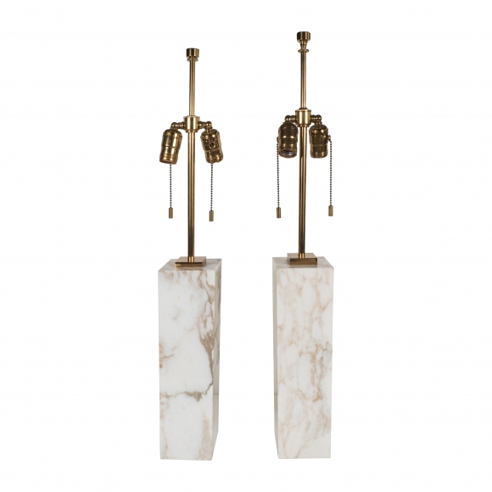

H: 30 W: 4 D: 4 in.

