SET OF 4 BLUE SWEDISH CERAMICS

Sweden, c. 1950's

EA4125

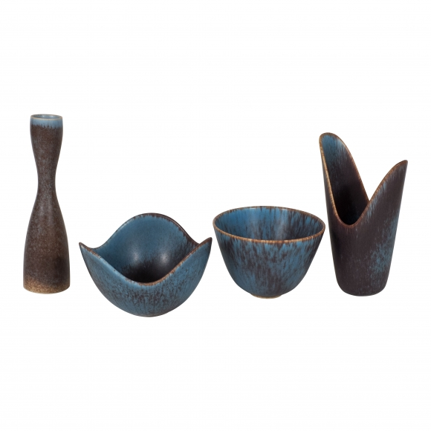

A- H: 3.5 Diam: 5.75 in. C- H: 8 Diam: 1.5 in.
B- H: 3.5 Diam: 5 in. D- H: 7 Diam: 4.25 in.

