Agate top TABLE WITH MIRRORED POLISHED BRONZE BASE

USA, Contemporary

EA4082D

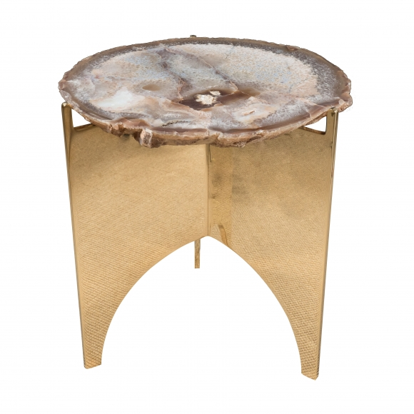
Dimensions: Diam: 16” H: 17”
Price: $11,000

