PETRIFIED WOOD TABLE WITH MIRRORED POLISHED BRONZE BASE

USA, Contemporary

c. 2016

EA4082H

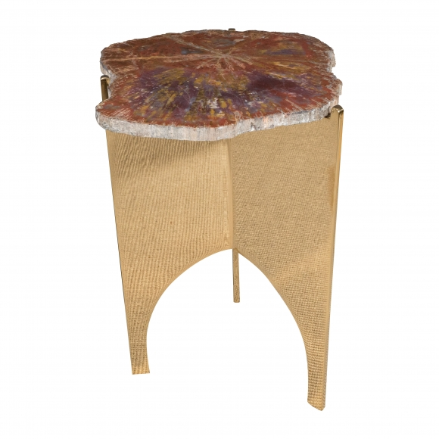
H: 18 W: 14 D: 11 in.

