ALDO TURA PARCHMENT LOW TABLE

Italy, c. 1960's

EA4091

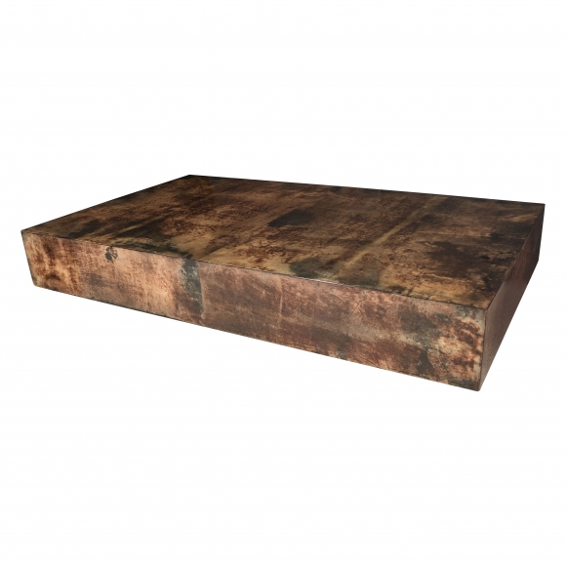
H: 14.25 W: 35.5 L: 59 in.

