FRENCH LUCITE AND BRASS CONSOLE WITH GLASS SHELVES AND TOP

France, c. 1960

EA4092
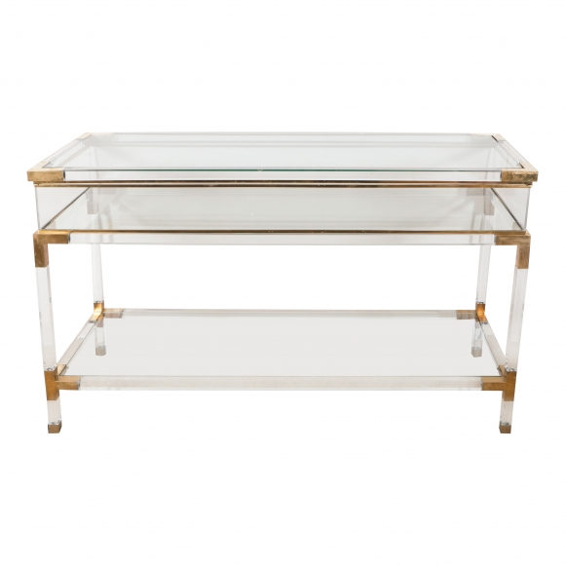
H: 32 L: 55.25 D: 20 in.

