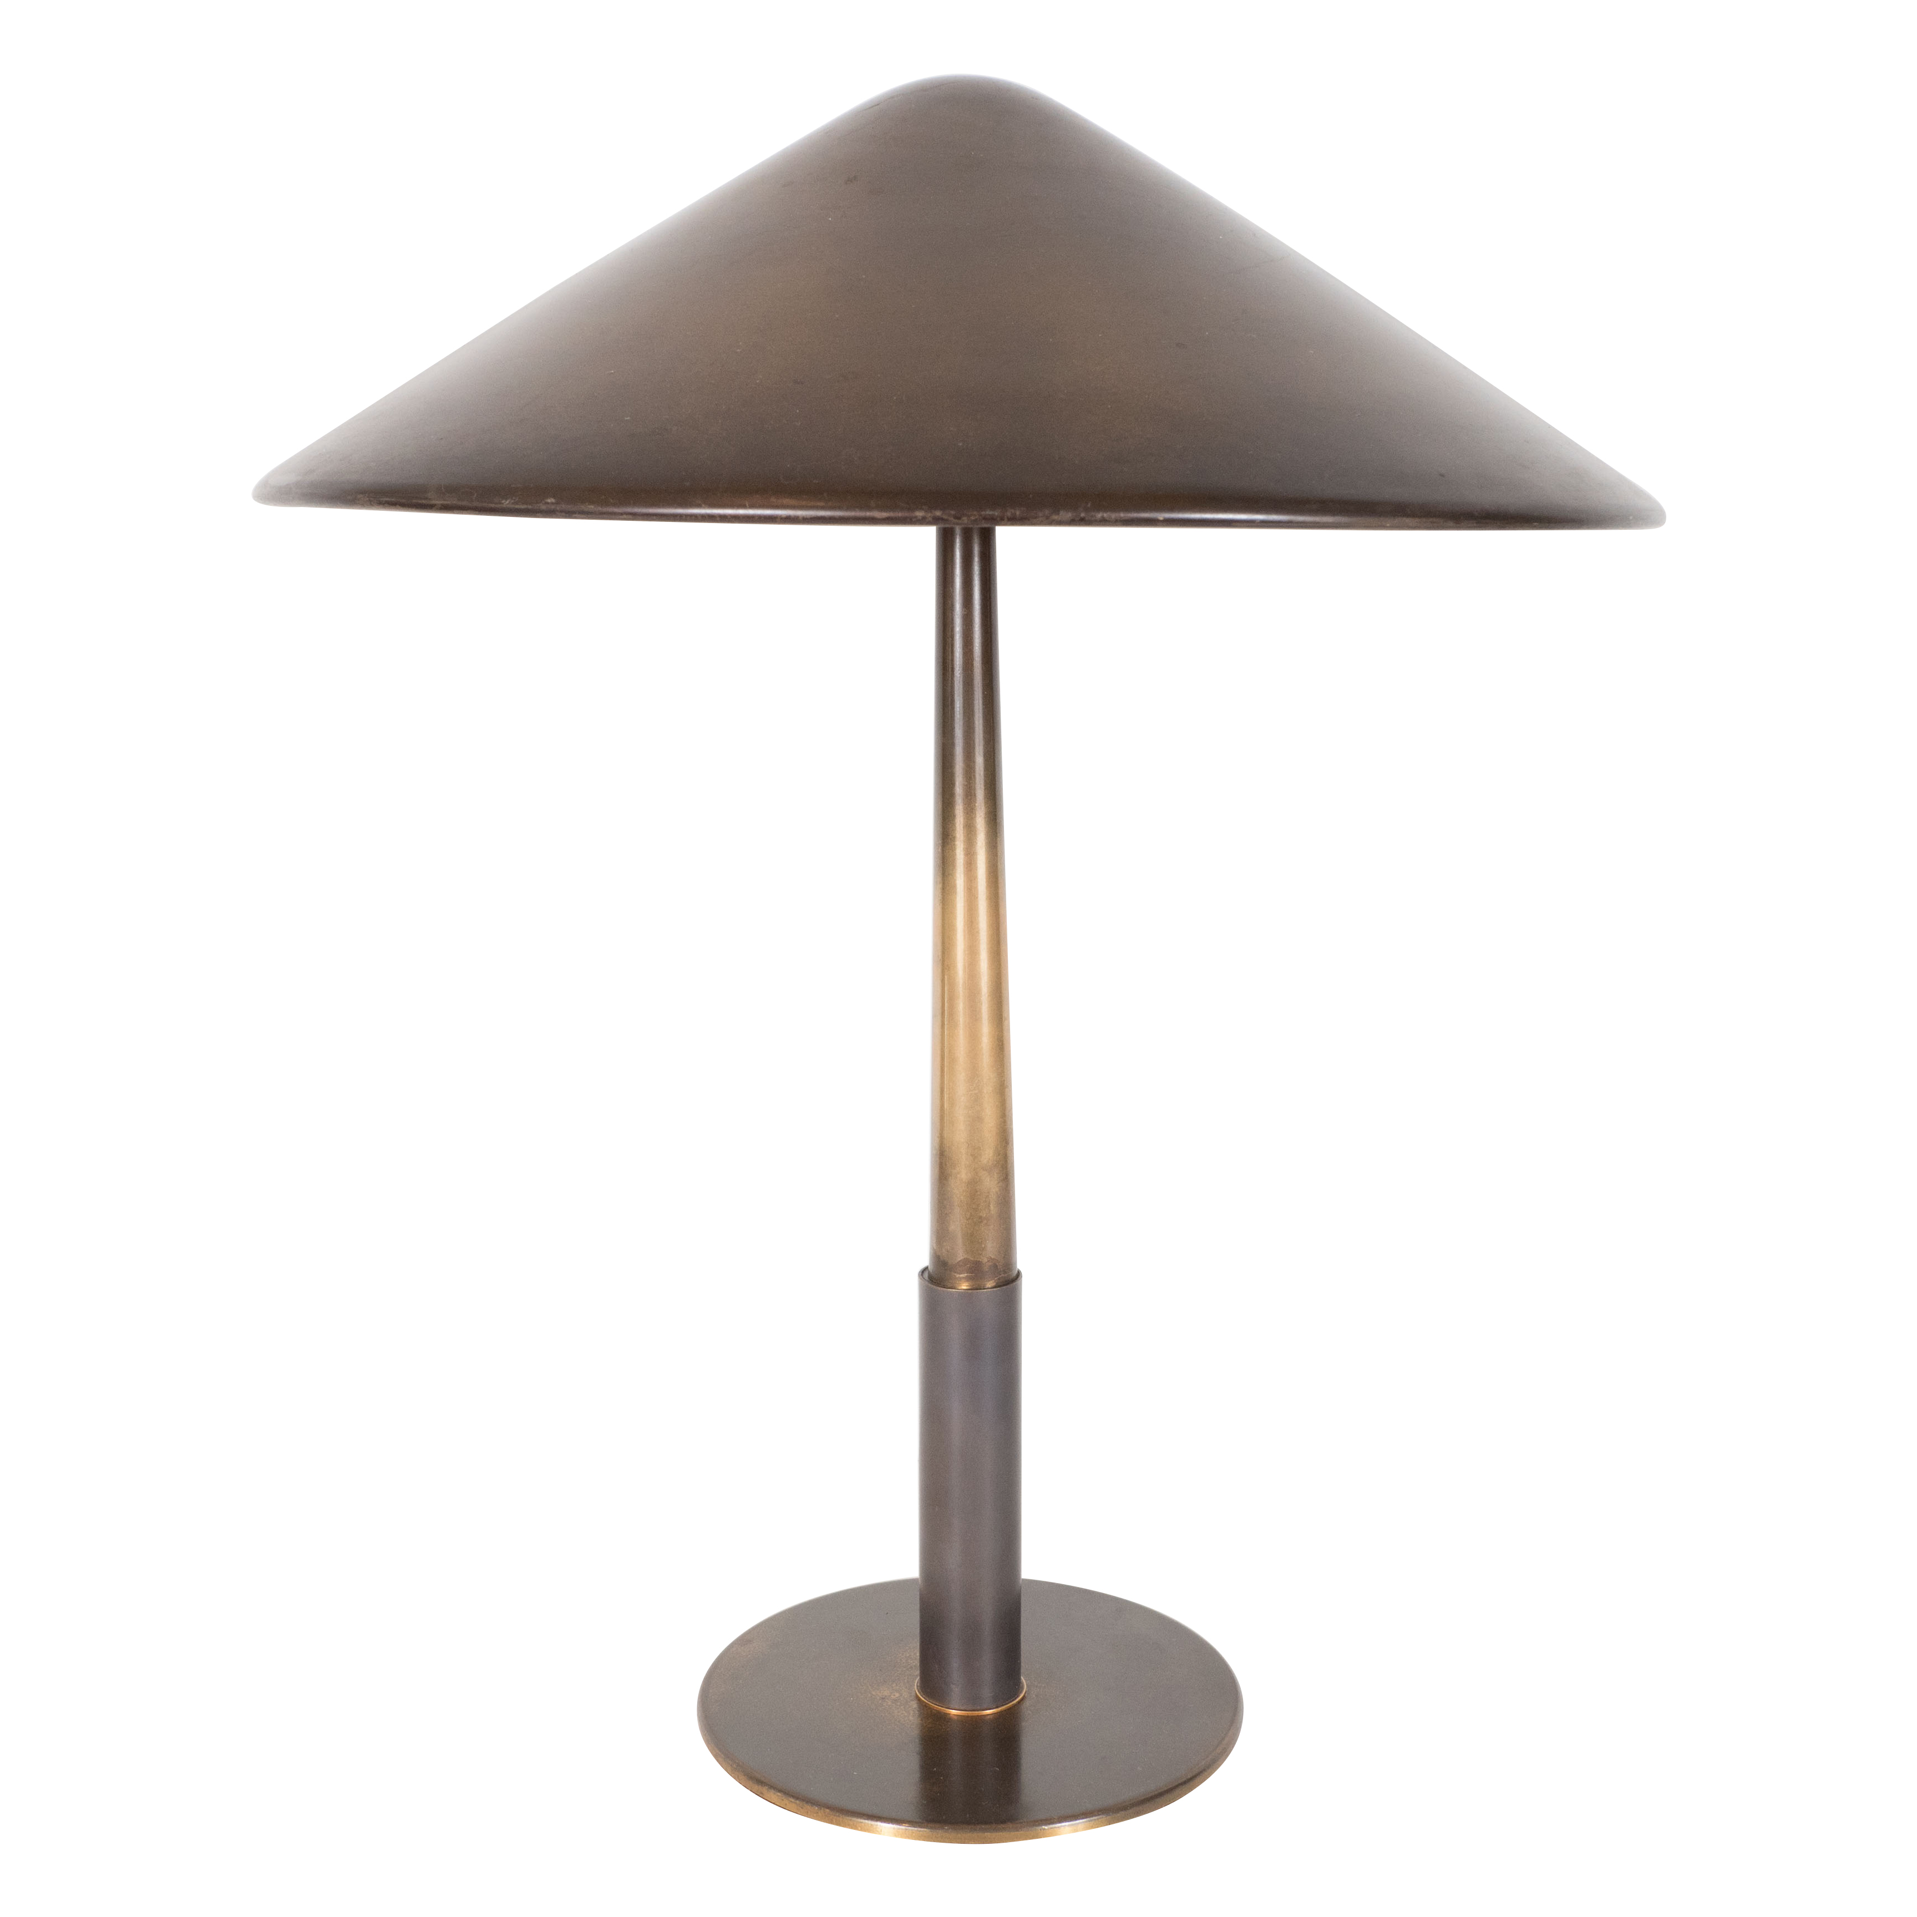
Bronze table lamp and shade by Stilnovo, Italy, 1950

Dimensions: Diam: 14.5” H: 19”

Item#: EA4045

Price: $5,625

