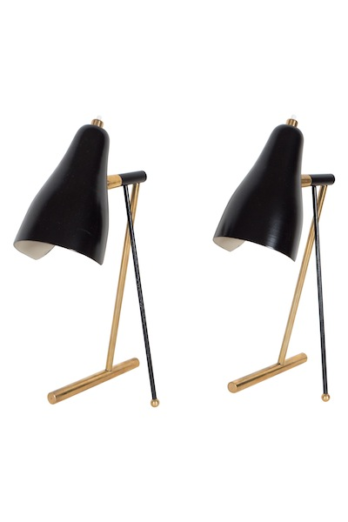
EA3995 Pair of Black Steel Small Gold Tripod Italian Bedside Table Lamps, Italy, 1950
H: 12 D: 4 W: 7 in.

$6,875

