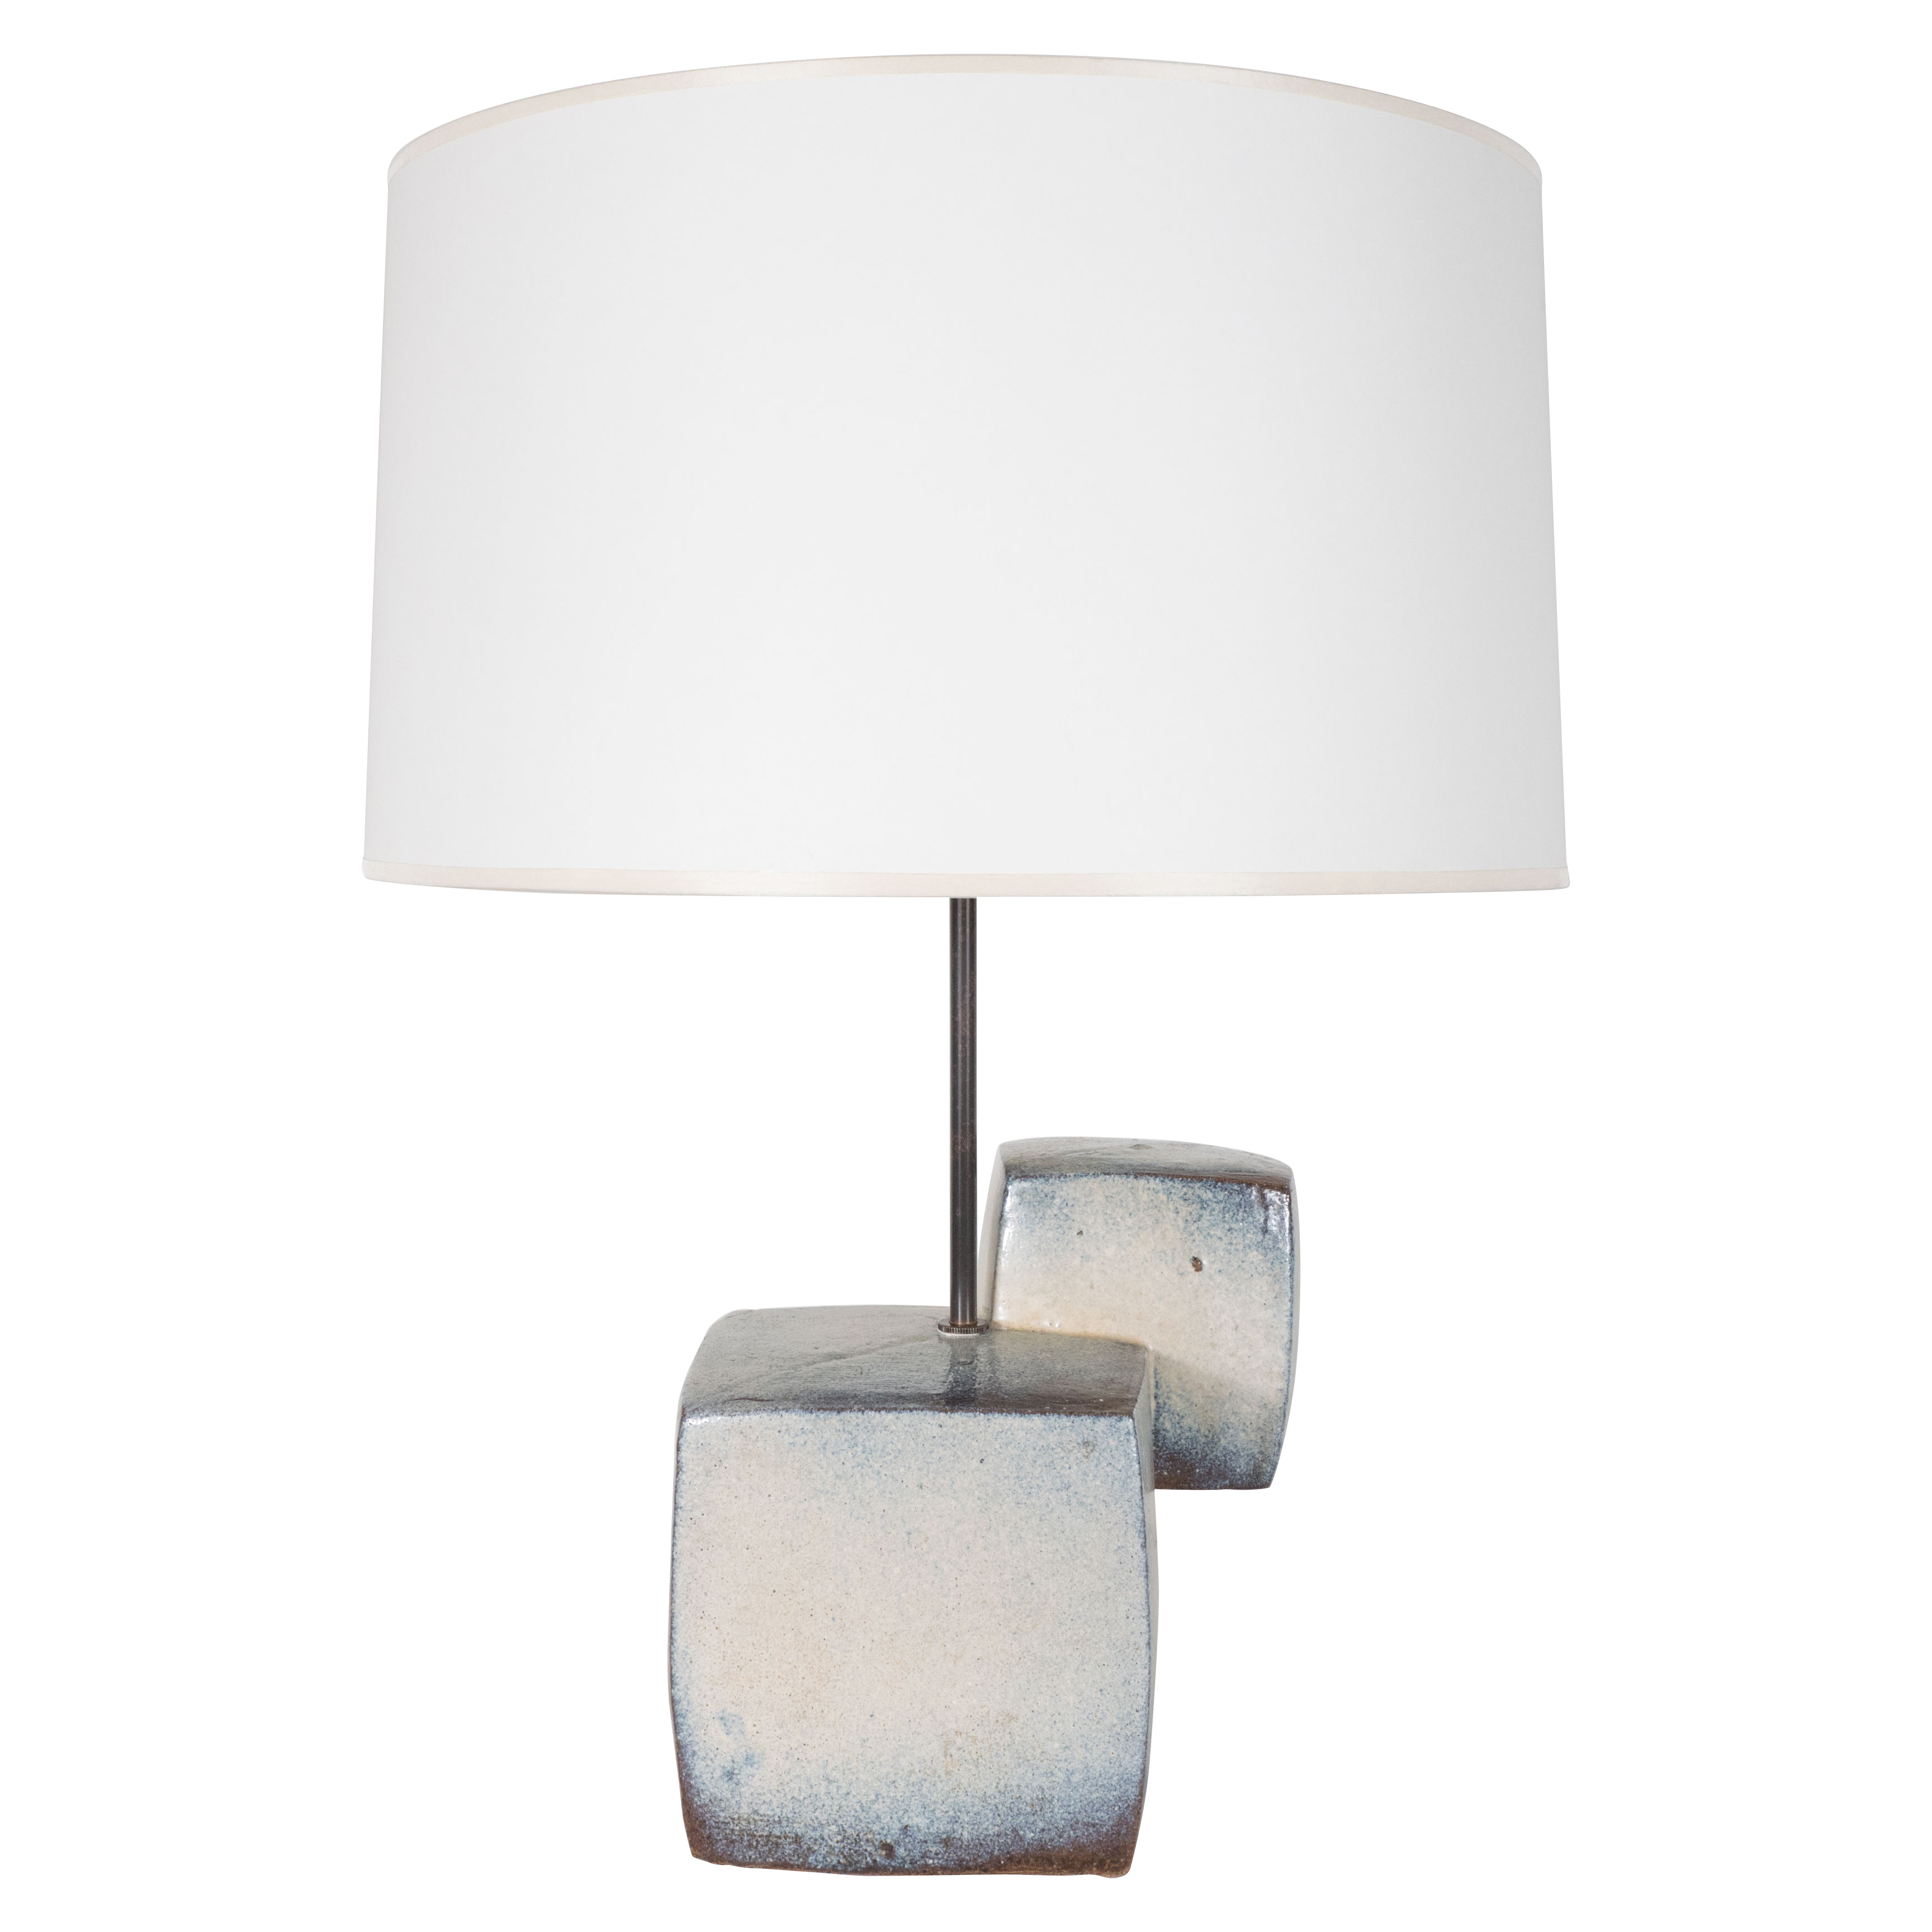

EA4115 Ceramic Lamp in Two Cube Form, Scandinavian, c. 1960 H: 21 D: 8.5 W: 8.5 in.

$5,625

