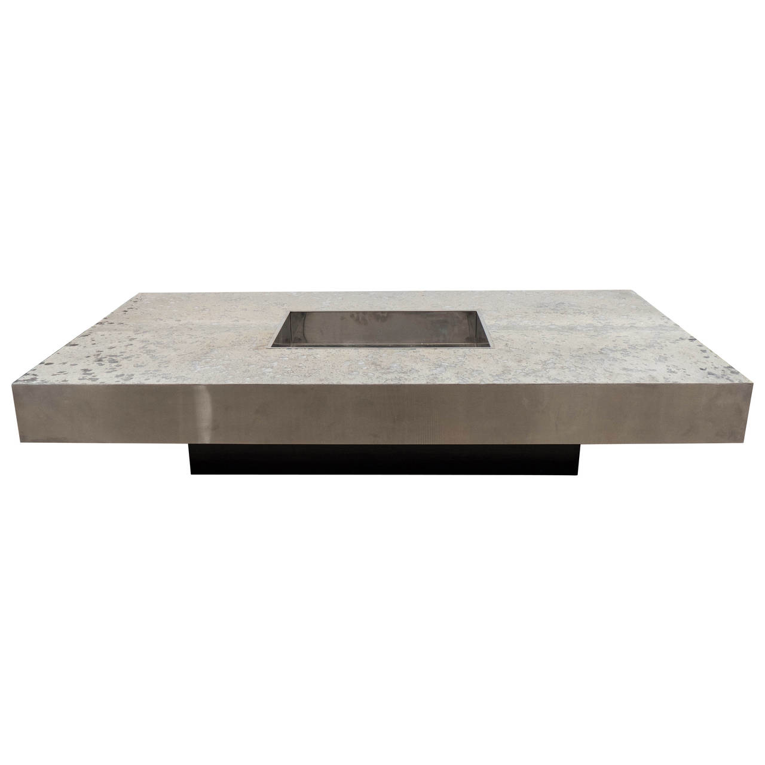

Willy Rizzo Low Table with Silver Leather Top, Italy circa 1970-1980

Dimensions: W: 63” D: 35.5” H: 12”

Item: EA4000

Price: $9,000

