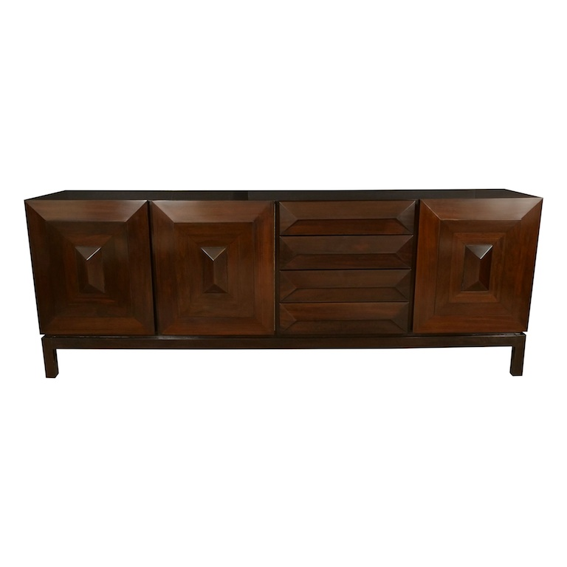

EA4145 Mahogany Sideboard with Squares Design, France, 1950 $17,500

H: 34 D: 20 W: 92.25 in.

