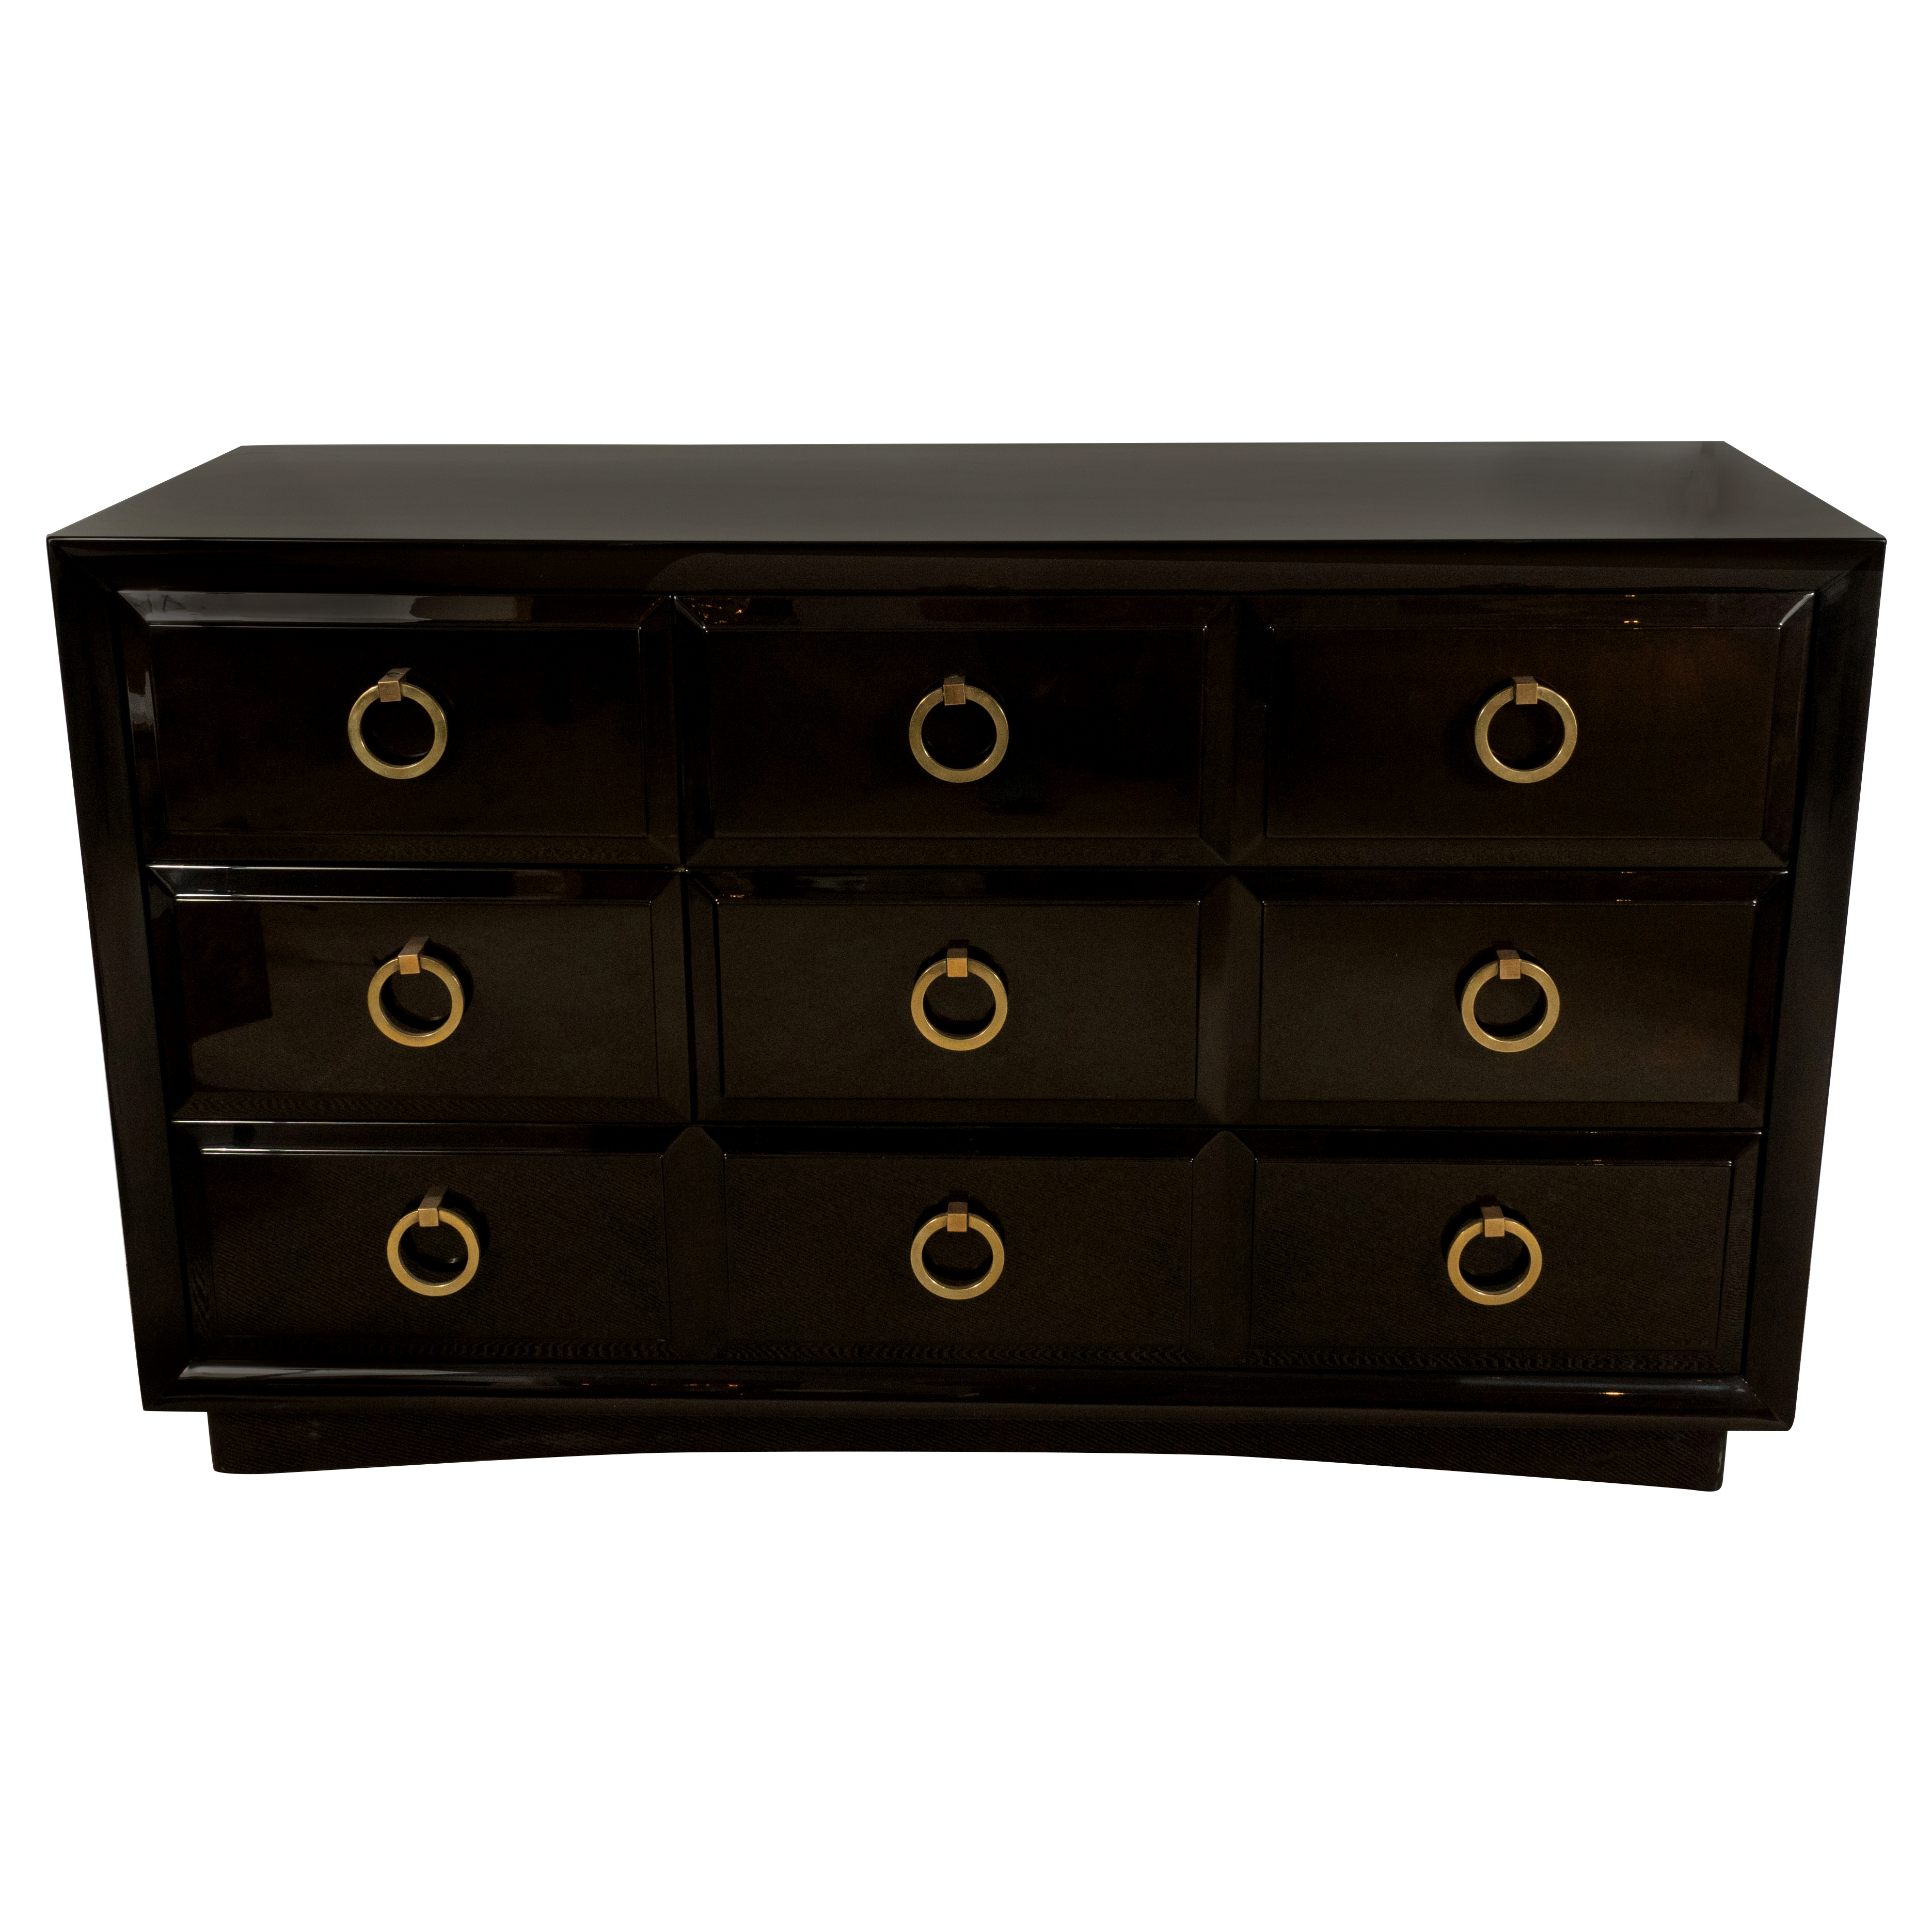

EA3163 A T. H. Robsjohn-Gibbings for Widdicomb three
drawer lacquered Chest, 1950s, two smaller
drawers on the left, bottom draw full length.
54” x 20.25” x 32.75” high. $10,625

