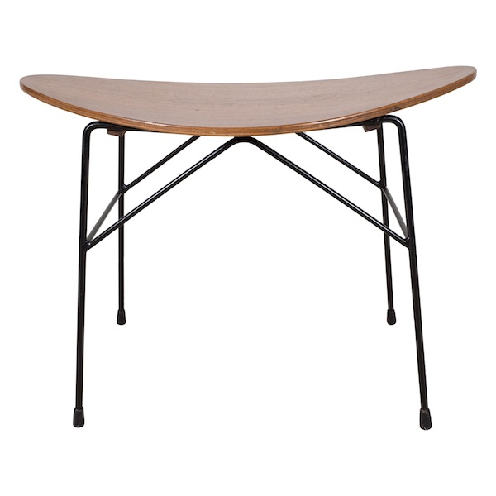

EA4141 Italian Stool by Pizzette, 1950’s H; 18.5 D: 12.5 W: 24.5 in. $5,625

