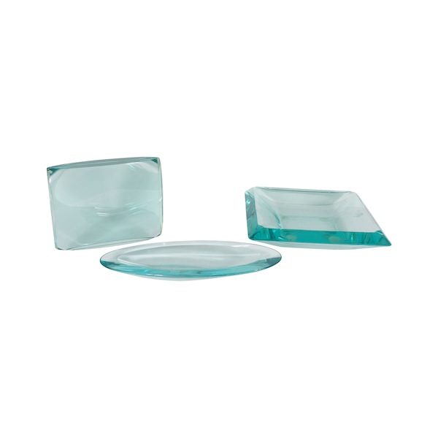

EA4096 Set of three Fontana Arte Pieces, Italy, 1960’s

Picture Frame- H: 7.75 W: 10 D: 2 in.
Square Ashtray/Cachepote- H: 3.25 W: 12.25 D: 12.25 in.
Oval Bowl- H: 1.5 W: 14.75 D: 6.25 in.

