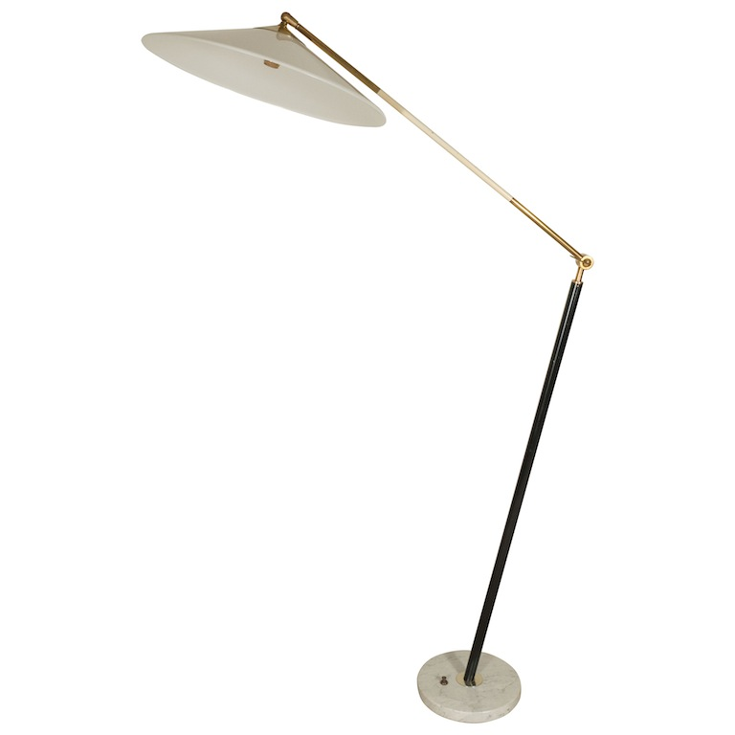

EA4162 Stilux Floor Lamp w White Plastic Shade, Italy $8,125
H: 60 D: 40 Diam base: 10 in.

