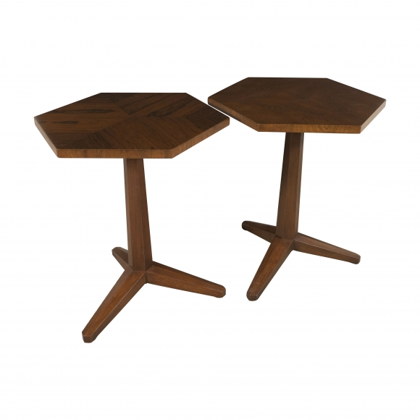

Pair of pedestal tables by Frank Lloyd Wright for Heritage, c. 1950

Dimensions: W: 18” D: 18” H: 20”

Item#: EA4187

Price: $7,000 / Pair

