Round side table with rattan and jute cord wrapped edge

Italy, c. 1965

EA4262

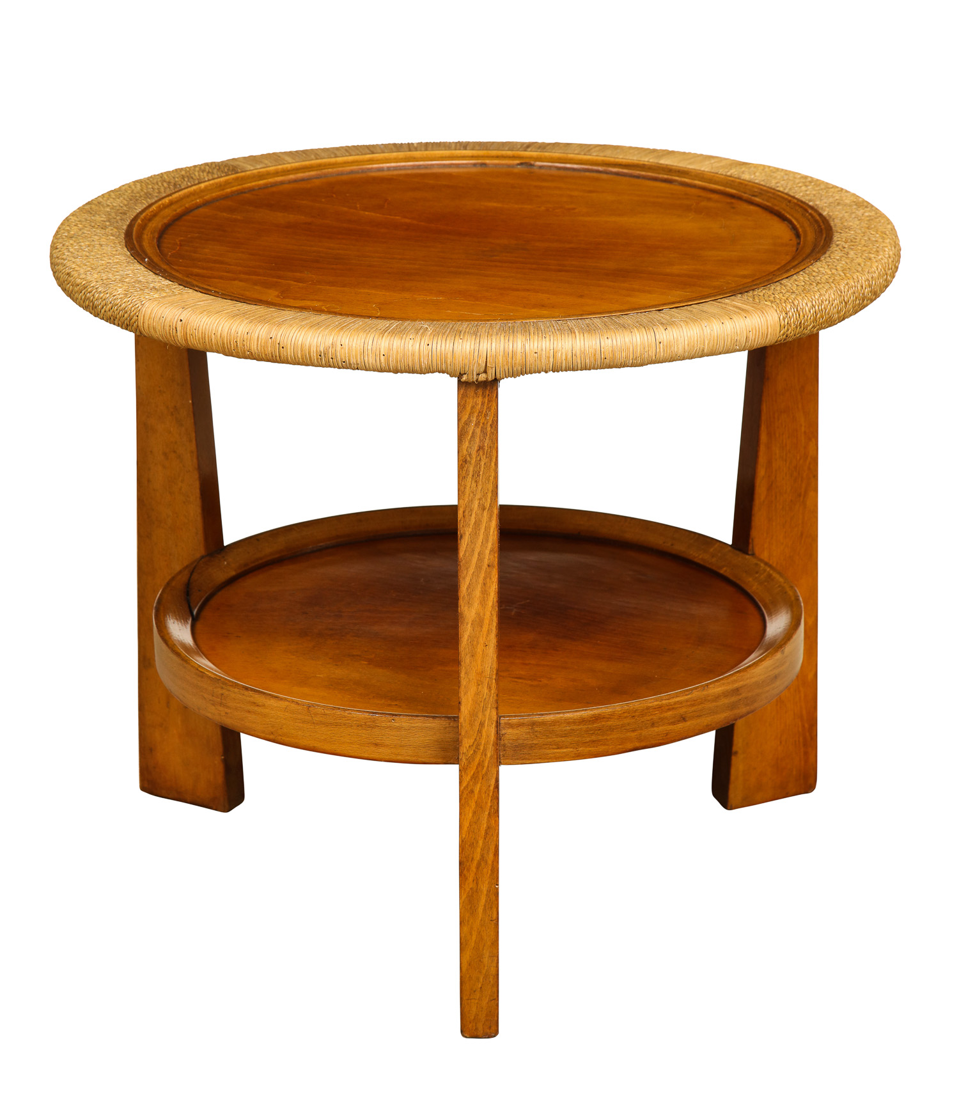

Dimensions: Diam: 24” H: 19”

Price: $5,500

