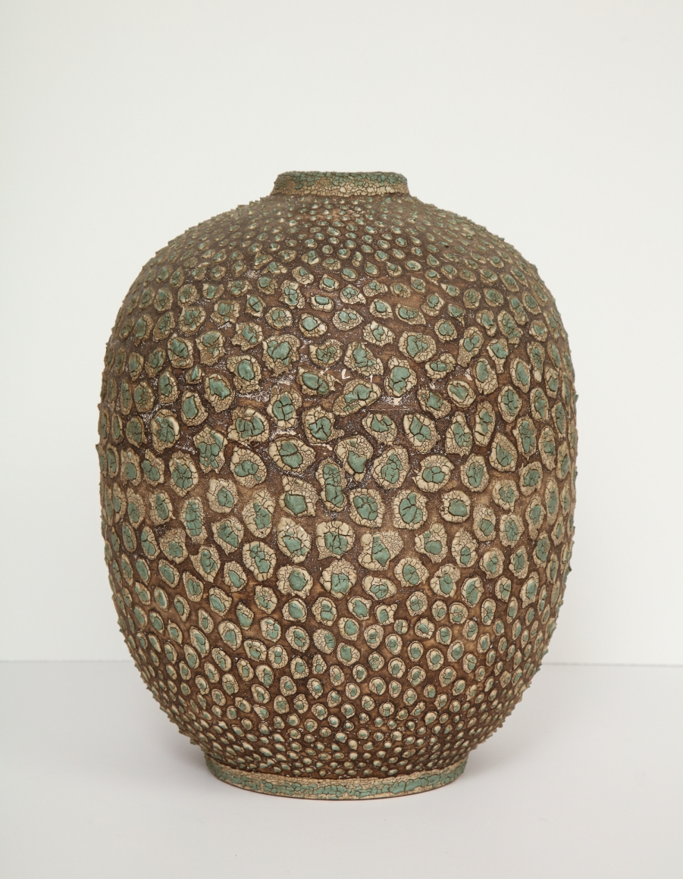

Large textured vessel with unique patina finish, France c. 1930
Diam: 10" H: 12.5"
Item#: EA4049
Price: $5,000

