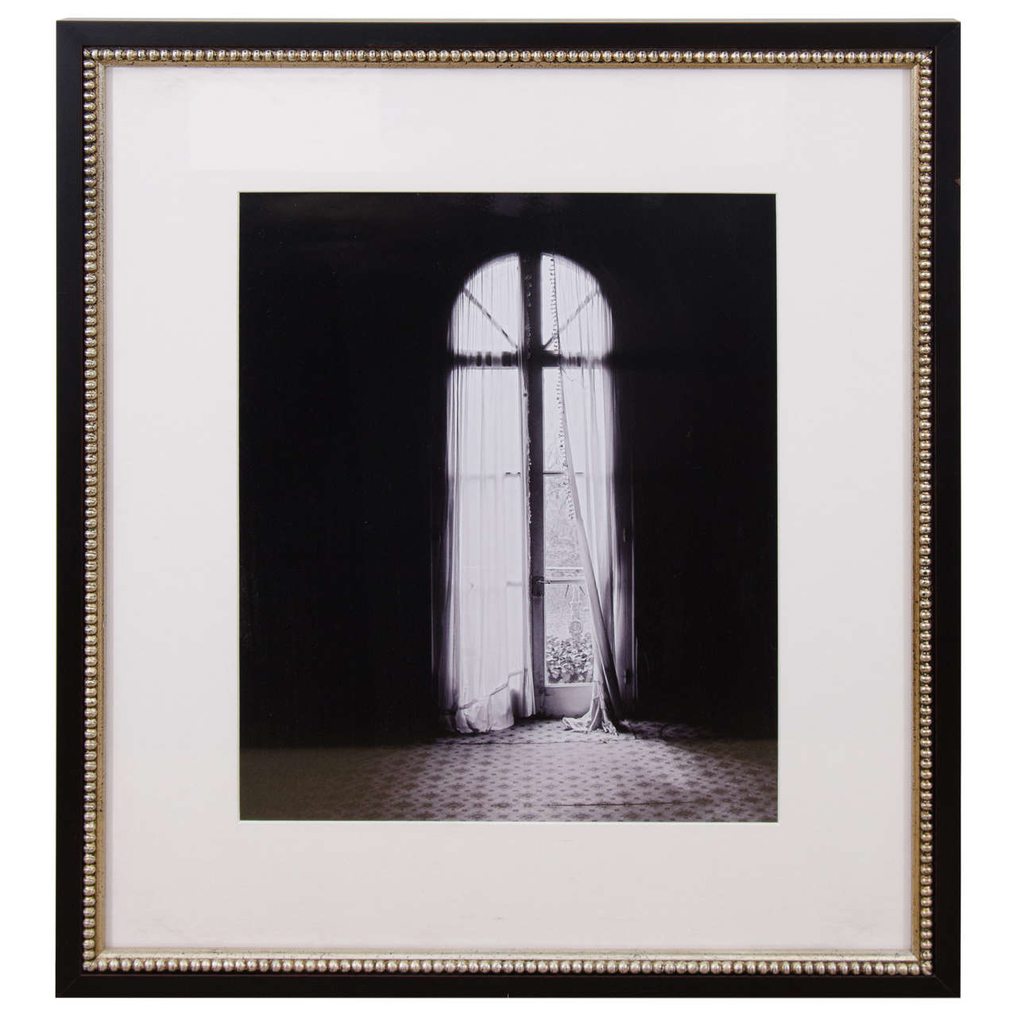

'Adieu Leves' Madeleine Castaing's home photograph by Barbara and Rene Stoeltie, from the exhibition 'Adieu Lèves' Galerie Mortier–Valat, Paris, 2006. Limited edition

Dimensions: W: 21.5” H: 24.5”

Item#: EA4302

Price: $3,000

