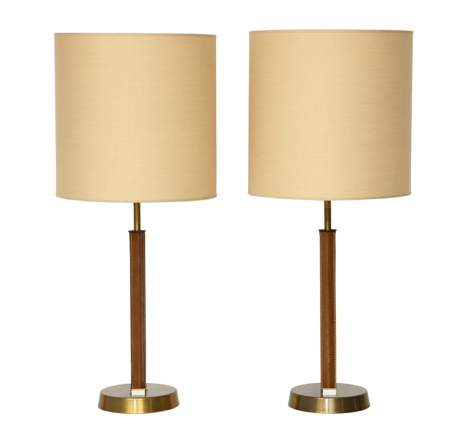

PAIR OF LEATHER AND BRASS TABLE LAMPS BY PHILIPS, Netherlands c. 1960

Dimensions: H: 28” Base: 6” Shade: Diam: 11” H: 12”

Item#: EA3901

Price: $5,625

