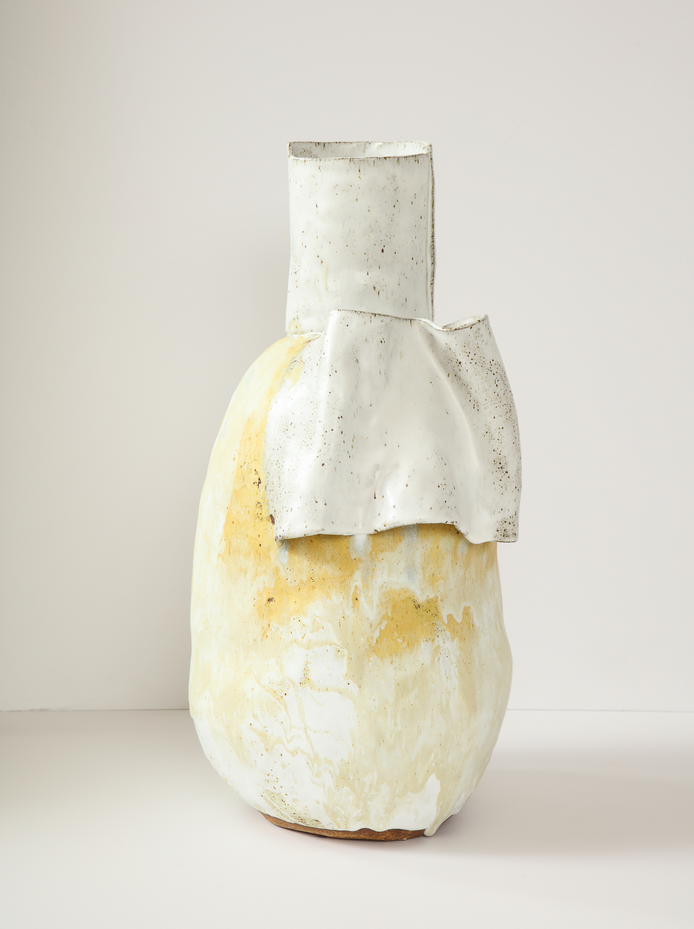
Caroline Blackburn Ceramics, Ca. USA Contemporary
EA4352
Dimensions: W: 10.5" H: 20.5"

