# LARGE ITALIAN MODERNIST MIRROR WITH BRASS FRAME

## Italy, c. 1950

### EA4028

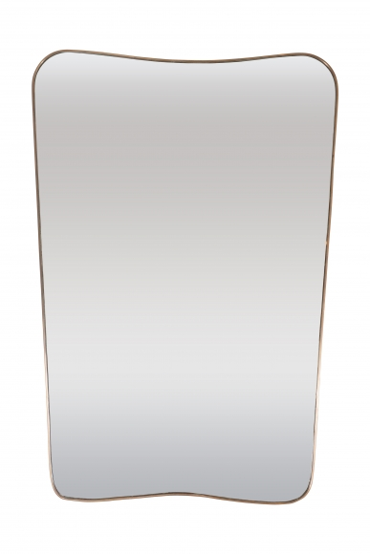

H: 50 W: 36 in.