Cerused oak SCULPTED FRONT NIGHTSTANDs by appel modern

Made to Order

AM3948

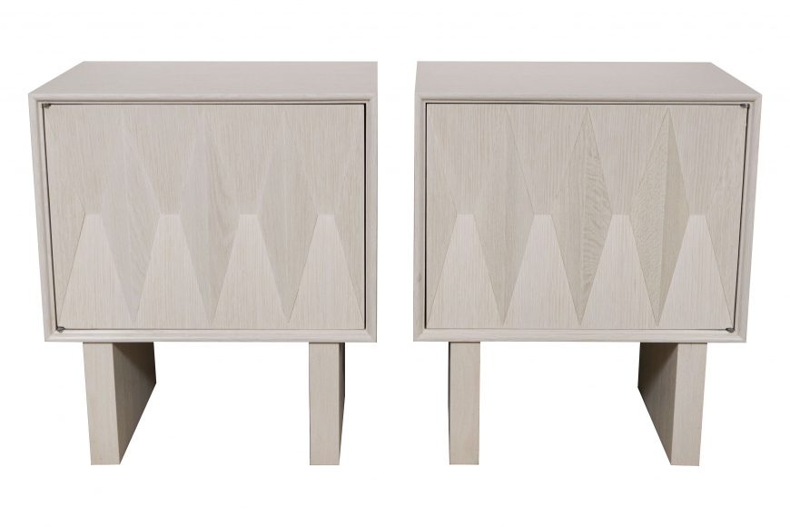

Pair of SCULPTED FRONT NIGHTSTAND WITH INTERIOR SHELF AND DRAWER by appel modern
Dimensions W: 22" D: 16" H: 26" | Custom Dimensions Available
Lead Time: 12 - 15 weeks
Finish: Light Cerused Oak | Custom Finishes Available
Price: Please Inquire

