# ANGELO LELLI BRASS AND LACQUERED METAL CEILING LIGHT

## Italy, c. 1954

### EA4061

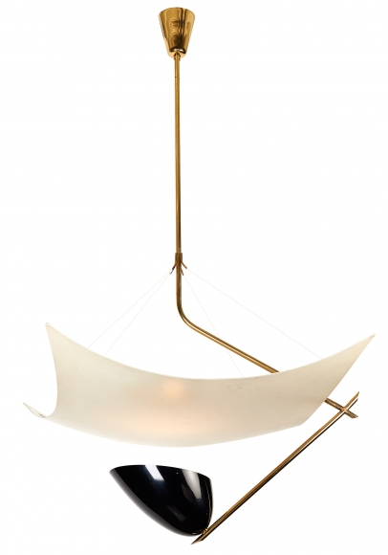

Angelo Lelli brass and lacquered metal ceiling light, Italy, c. 1954, executed by Arredoluce.

H: 37 W: 22.5 in.