# MURANO BLACK MICA SOMMERSO ART GLASS BOX

## Italy, c. 1950

### EA4133

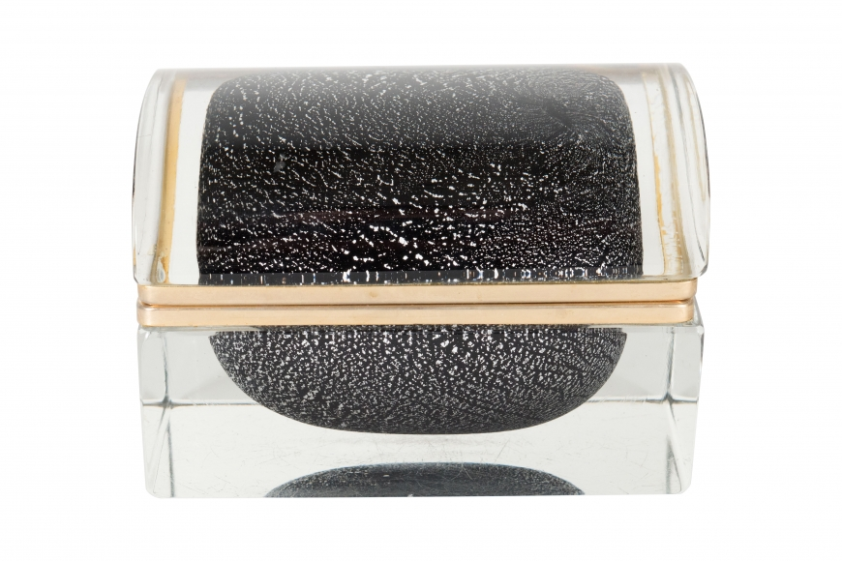

H: 3.5 W: 5.25 D: 4 in.