WHITE CRACKLE LAMP WITH LONG NECK

USA, c. 1950's

EA3969
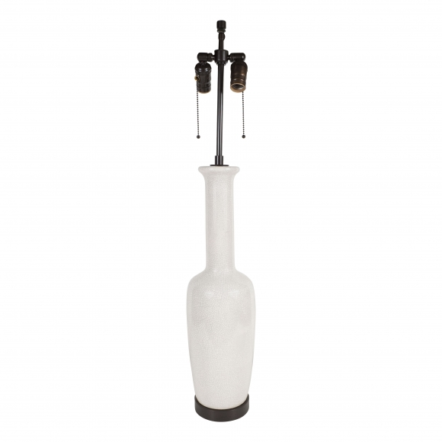

H: 33.5 Diam: 5 in.

