# PAIR OF LARGE CHARTREUSE LAMPS

## USA, c. 1950's

### EA4009

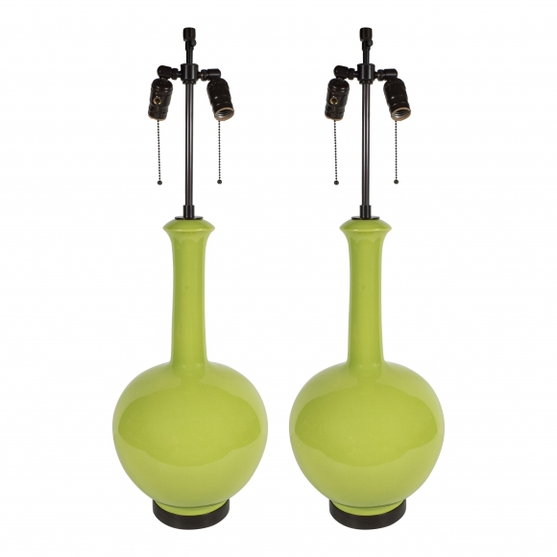

H: 32.5 Diam: 10 in. 