# ITALIAN MODERNIST MIRROR WITH BRASS FRAME

## Italy, c. 1960

### EA4058

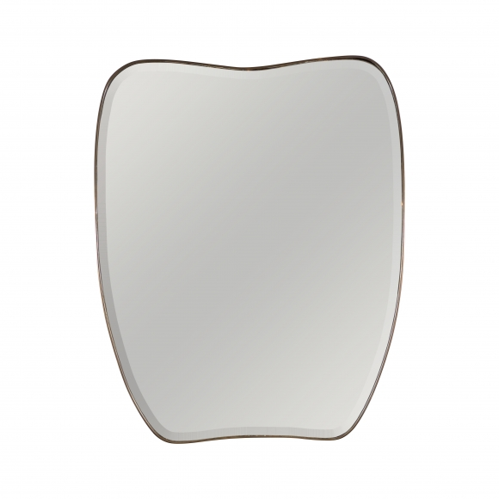

H: 39.5 W: 31.5 in.